CGI

📘 Definition
# Source: AI Source: Provided by: [Data Path: Persons Table -> ID Column: 1, Name_En Column: Motasem Essam] -> From: [ChatGPT] on [5/2/2026]
CGI (Computer-Generated Imagery) is the use of computers to create images, scenes, or animations that may look real or imaginary.
It is widely used in movies, video games, and visual effects to create things that are difficult or impossible to film in real life.

🖥️ How CGI works
# Source: AI Source: Provided by: [Data Path: Persons Table -> ID Column: 1, Name_En Column: Motasem Essam] -> From: [ChatGPT] on [5/2/2026]
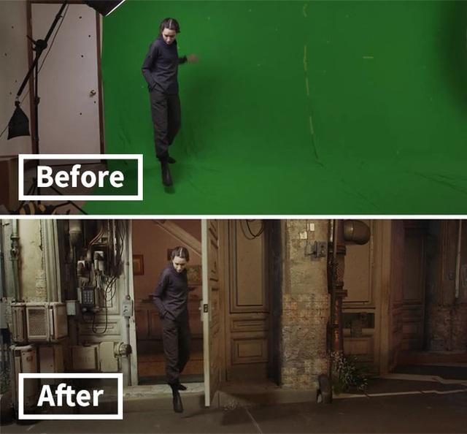
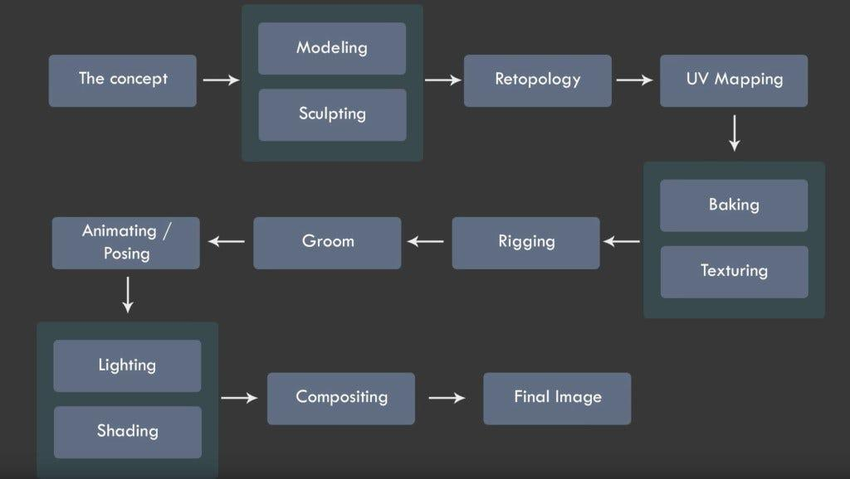
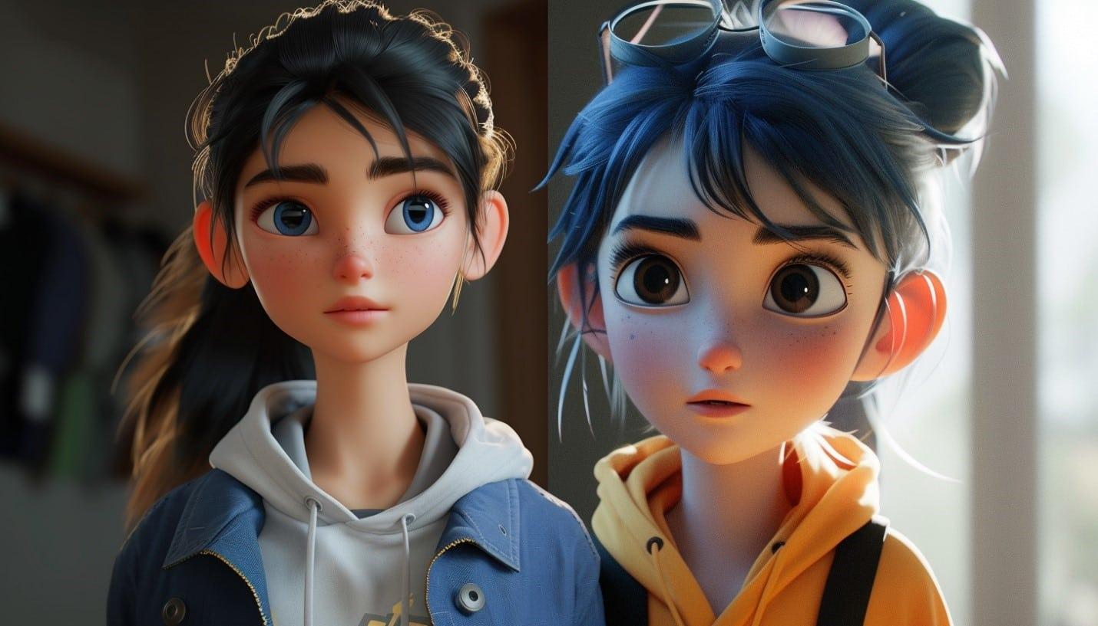
CGI involves several steps:
- 🧊 Modeling → creating 3D objects
- 🎨 Texturing → adding colors and details
- 💡 Lighting → simulating light and shadows
- 🎞️ Animation → adding movement
- 🖥️ Rendering → producing the final image

🧠 Simple example
# Source: AI Source: Provided by: [Data Path: Persons Table -> ID Column: 1, Name_En Column: Motasem Essam] -> From: [ChatGPT] on [5/2/2026]
Think of:
- 🦖 Dinosaurs in movies
- 🦸 Superheroes flying or using powers
- 🎮 Characters and worlds in video games
These are often created using CGI.

🎮 Where CGI is used
# Source: AI Source: Provided by: [Data Path: Persons Table -> ID Column: 1, Name_En Column: Motasem Essam] -> From: [ChatGPT] on [5/2/2026]
- 🎬 Movies (visual effects, animation films)
- 🎮 Video games
- 📺 TV shows and commercials
- 🏗️ Architecture and product design

⚙️ Key features
# Source: AI Source: Provided by: [Data Path: Persons Table -> ID Column: 1, Name_En Column: Motasem Essam] -> From: [ChatGPT] on [5/2/2026]
- 🖥️ Created using computers
- 🌍 Can be realistic or imaginary
- 🎨 Combines modeling, lighting, and rendering
- 🎬 Used for animation and visual effects

🚀 In short:
# Source: AI Source: Provided by: [Data Path: Persons Table -> ID Column: 1, Name_En Column: Motasem Essam] -> From: [ChatGPT] on [5/2/2026]
CGI = images and animations created using computers, commonly used in movies, games, and visual effects.

